Media Contact: Aislinn Scofield
(415) 585-9776,
earplay@earplay.org
PO Box 192125
San Francisco, CA 94119-2125

www.earplay.org
FOR IMMEDIATE RELEASE
CLASSICAL MUSIC

Earplay 23: Facets and Lines
(SAN FRANCISCO, CA – October 12, 2007)

November 12
San Francisco’s Herbst Theatre at 7:00 p.m.

Earplay 23: Facets and Lines opens Earplay’s 23rd season celebrating the vibrancy and diversity of the Bay Area new music scene. Works Pulitzer Prize-winning composer, Wayne Peterson and Stanford composer, Mark Applebaum, as well as a premier by U.C. Davis composer, Laurie San Martin. Each of these composers represents a different facet of Bay Area contemporary music. The Heart’s Ear by Australian composer, Liza Lim is a richly layered sonic landscape providing an excellent complement to the rhythmic vitality and intricacy of Peter Maxwell Davies’ The Economies of Scale.

Program:

Mark Applebaum Entre Funerailles IV (2000)
Liza Lim Heart’s Ear (1997)
Peter Maxwell Davies The Economies of Scale (2002)
Wayne Peterson Duo (1993)
Laurie San Martin Dances (2007)*
Barbara White Mind’s Fear/Heart’s Delight (1998) *

* premiere
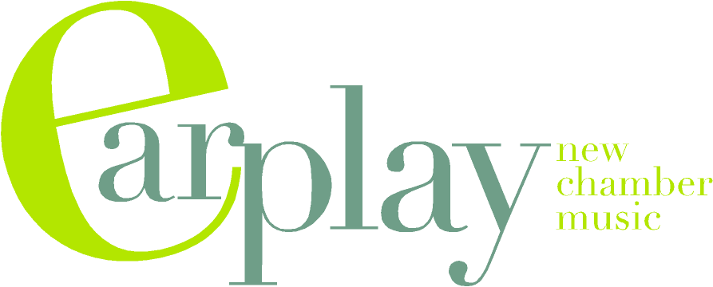

Media Contact: Aislinn Scofield
(415) 585-9776
earplay@earplay.org
PO Box 192125
San Francisco, CA
94119-2125
www.earplay.org

(October 12, 2007 – San Francisco, CA) EARPLAY, the new chamber music ensemble renowned for its bold programming and first-rate performances, opens its 23rd annual season Monday, November 12 with Earplay 23: Facets and Lines, a program that celebrates the vibrancy and diversity of the Bay Area new music scene. The program will include works Pulitzer Prize-winning composer, Wayne Peterson and Stanford composer, Mark Applebaum, as well as the premier by U.C. Davis composer, Laurie San Martin. Each of these composers represents a different facet of Bay Area contemporary music. The program will also include The Heart’s Ear by Australian composer, Liza Lim. This richly layered sonic landscape will provide an excellent complement to the rhythmic vitality and intricacy of Peter Maxwell Davies’ The Economies of Scale. Karen Rosenak (piano) will premiere Laurie San Martin’s new work Dances based upon tangos. Tod Brody is the soloist in Mark Applebaum’s Entre Funerailles IV (2000). Terrie Baune (violin) and Karen Rosenak (piano) perform in Wayne Peterson’s rhythmic Duo. Peter Josheff (clarinet), Lisa Weiss, Thalia Moore (cello), Karen Rosenak perform in Peter Maxwell Davies’ The Economies of Scale. Mary Chun will conduct Barbara White’s Mind’s Fear/Hear’s Delight (1998) with Tod Brody, Peter Josheff, Lisa Weiss, Dan Reiter, Karen Rosenak and Dan Kennedy. Maestra Chun also conducts Liza Lim’s Heart’s Ear.
Program notes at www.earplay.org

EARPLAY has performed over 400 works in its 23-year history including 104 world premieres and 45 new works commissioned by the ensemble. This season will reinforce EARPLAY’s unwavering track record of presenting exceptional music in the 21st century. During the 2007-08 season Earplay will inaugurate a new programming concept, in which the ensemble celebrates the work of a major contemporary composer by performing a cross-section

of his or her work over the course of the season. Each of the three concerts of the 2007-08 season will feature a work by the British composer, Peter Maxwell Davies placed in context
with works by a diverse group of local and international composers. Among the most prominent European composers after 1950, Davies is known for his references to music of the distant past, particularly Medieval music. The centerpiece of the season will be Davies’ Ave Maris Stella, a stunning 25’ sextet from 1975 that incorporates elements of medieval music into a virtuosic piece of chamber music. This piece is rooted as much in Arnold Schoenberg’s expressionist masterpiece, Pierrot Lunaire, as it is in the 14th century music of Guillaume de Machaut. The far-reaching plurality of influences present in Davies music serves as the backdrop for each of the programs. Alongside Davies’ music, Earplay continues its commitment to championing the work of local Bay Area composers and emerging composers, as well as important composers from around the world.

Additional Performances:
This year Earplay was invited to perform two concerts at the Festival of New American Music at Sacramento State University.
EARPLAY: Sonic Bloom, Composers of the Central Valley (November 3)
EARPLAY: Wayne Peterson at 80 (November 5)
Featuring compositions by Pulitzer Prize-winning composer Wayne Peterson

Founded in 1985 by a consortium of composers and musicians, Earplay is dedicated to the performance of new chamber music offering audiences a unique opportunity to hear eloquent, vivid performances of some of today's finest chamber music. Earplay concerts feature the Earplayers, a group of seven artists who, as a group, have developed a lyrical and ferocious style. For more information, please visit www.earplay.org.

Mary Chun conducts the Earplayers, a group of six outstanding Bay Area musicians: Tod Brody, flute and piccolo; Peter Josheff, clarinet and bass clarinet; Terrie Baune, violin; Ellen Ruth Rose, viola; Thalia Moore, cello, and Karen Rosenak, piano.

30

Media Contact: Aislinn Scofield
(415) 585-9776, earplay@earplay.org

October 7, 2007
PO Box 192125
San Francisco, CA 94119-2125
415 585 9776
www.earplay.org

CALENDAR LISTING

Earplay 23: Facets and Lines

Please note: High-res jpegs available upon request

WHO: EARPLAY 23: Facets and Lines
Featuring compositions by Mark Applebaum, Peter Maxwell Davies, Liza Lim, Laurie San Martin, Wayne Peterson and Barbara White.
WHEN: Monday, November 12, 2007
TIME: 7:00 p.m.
6:15 p.m. pre-concert talk
WHERE: Herbst Theatre, 401 Van Ness Avenue, San Francisco
TICKETS: $20 General, $10 students/seniors
City Box Office, (415) 392-4400, www.cityboxoffice.com

Mary Chun conducts the Earplayers, a group of six outstanding Bay Area musicians: Tod Brody, flute and piccolo; Peter Josheff, clarinet and bass clarinet; Terrie Baune, violin; Ellen Ruth Rose, viola; Thalia Moore, cello, and Karen Rosenak, piano. In November they are joined by exceptional Bay Area artists, Lisa Weiss, violin, Dan Reiter, cello, Dan Kennedy and Jim Kassis, percussion.

SPECIAL PERFORMANCES:

WHO: Festival of New American Music
EARPLAY: Sonic Bloom, Composers of the Central Valley (November 3)
EARPLAY: Wayne Peterson at 80 (November 5)
Featuring compositions by Pulitzer Prize-winning composer Wayne Peterson
WHEN: Saturday, November 3 and Monday, November 5
TIME: 7:00 p.m.
WHERE: Sacramento State University
TICKETS: Free

EARPLAY 23 SEASON

Earplay 23: Facets and Lines (November 12)
Earplay 23: Unorthodox Journeys (February 11)
Earplay 23: Intricate Inventions (May 28)
May 28 is part of the San Francisco International Arts Festival

All performances at San Francisco’s Herbst Theatre at 7:00 p.m.

